PROJECT REPORT
Google Maps Business Scraper and Automated Backup System
A Playwright-based data collection solution for extracting business listings, addresses, images, phone numbers, ratings, and reviews with retry handling, progress recovery, and Google Drive synchronization.

Project Type | Web Scraping and Data Pipeline
Core Language | Python
Automation Framework | Playwright, pandas, threading
Storage / Backup | CSV files + rclone to Google Drive
Scope | Multi-state business extraction
Prepared for Office Submission

1. Executive Summary
This project is a resilient data collection system built to automate the extraction of Google Maps business listings for the electricians category. The scraper visits search results city by city, opens each business profile, captures core business information, downloads available images, and collects reviews when accessible. To support long-running execution, the script includes browser health checks, retry logic, progress tracking, heartbeat updates, and automatic recovery after browser crashes. A background rclone copy process synchronizes the local output folder to Google Drive so the collected data is preserved off the machine.

2. Project Objective
The main objective is to create an automated and fault-tolerant scraping pipeline that can gather structured business data across multiple U.S. states and cities with minimal manual intervention. The project is designed for practical field use, where interruptions, unstable pages, and large-scale batch processing are expected.

3. Tools and Technologies Used
Technology | Purpose
Python | Core scripting and automation
Playwright | Browser automation and page interaction
pandas | Tabular data handling and CSV export
threading / ThreadPoolExecutor | Concurrent state-level processing
rclone | One-way Google Drive backup
re / urllib / subprocess | Text processing, image download, and external command execution

4. System Overview
The solution is organized around a city-level scraping workflow. For each city, the script constructs a Google Maps search URL, opens the results, scrolls until additional businesses stop loading, and extracts business cards from the list. Each business is then opened individually to collect detailed profile data such as the address, image URL, and review content. Results are saved to state-specific CSV files under a structured output directory, making the data easy to review and reuse.

5. Key Functional Modules
Module | Role
Address Parsing | Splits full addresses into street, city, state, and ZIP code
City Search URL Builder | Creates Google Maps queries for each city and state
Business Detail Scraper | Opens each business profile and extracts contact and location data
Review Scraper | Clicks the reviews section and captures review text, rating, reviewer name, and date
Image Downloader | Downloads the main business image and stores it in a structured folder
Progress Tracker | Saves the last processed state and city for recovery after interruption
Drive Sync | Copies completed output to Google Drive using rclone

6. Workflow
- The script selects a state and a city from the configured location list.
- It loads the Google Maps search results and scrolls the results container until no new entries appear.
- Business cards are parsed to collect the business name, profile URL, phone number, rating, and website.
- Each business page is opened to extract the full address and optional image.
- The reviews tab is opened when available and visible reviews are collected.
- Data is written to CSV files, progress is updated, and the output is copied to Google Drive.

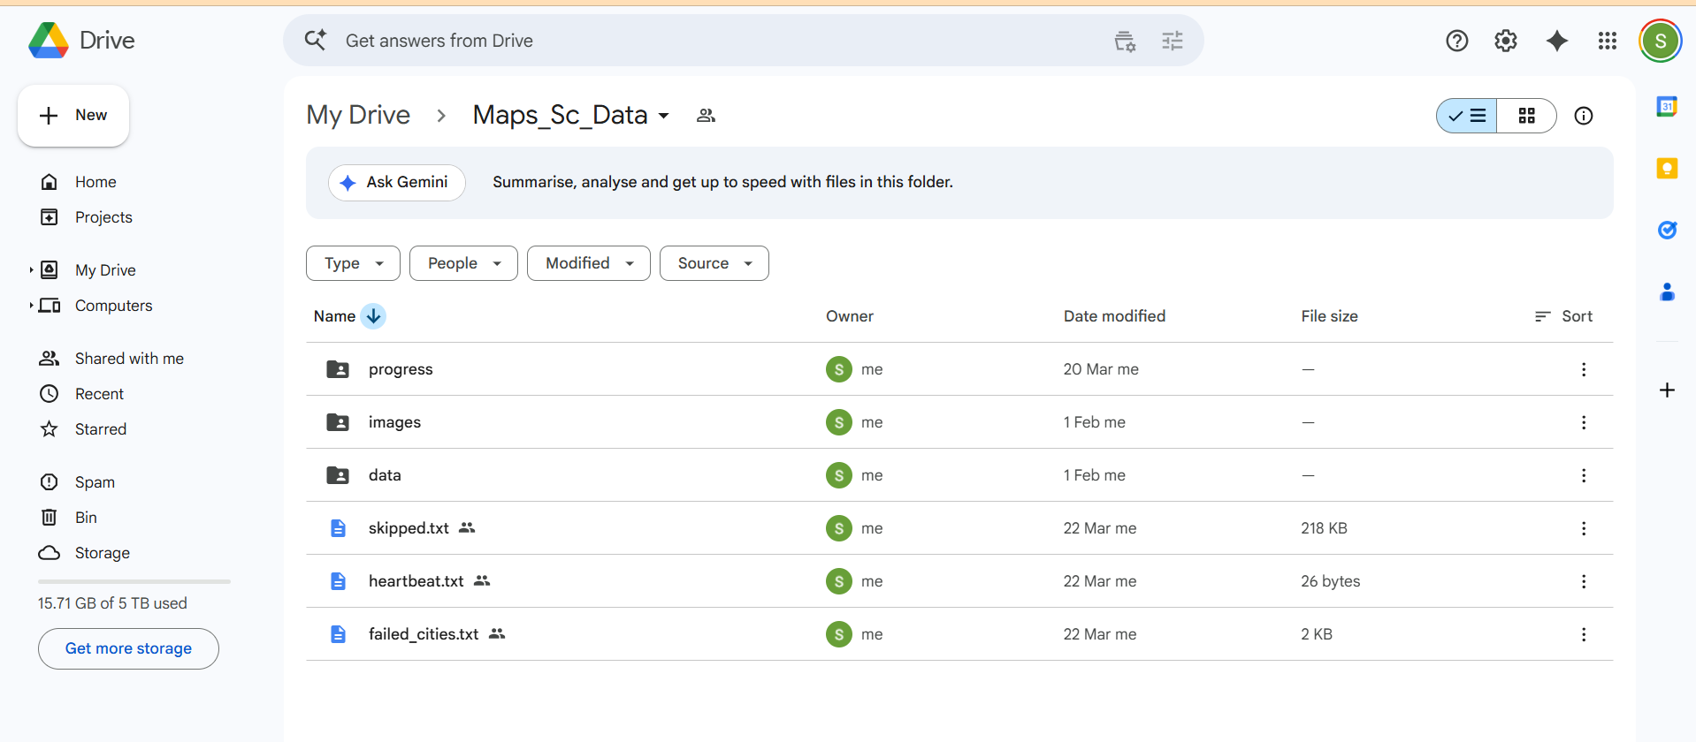
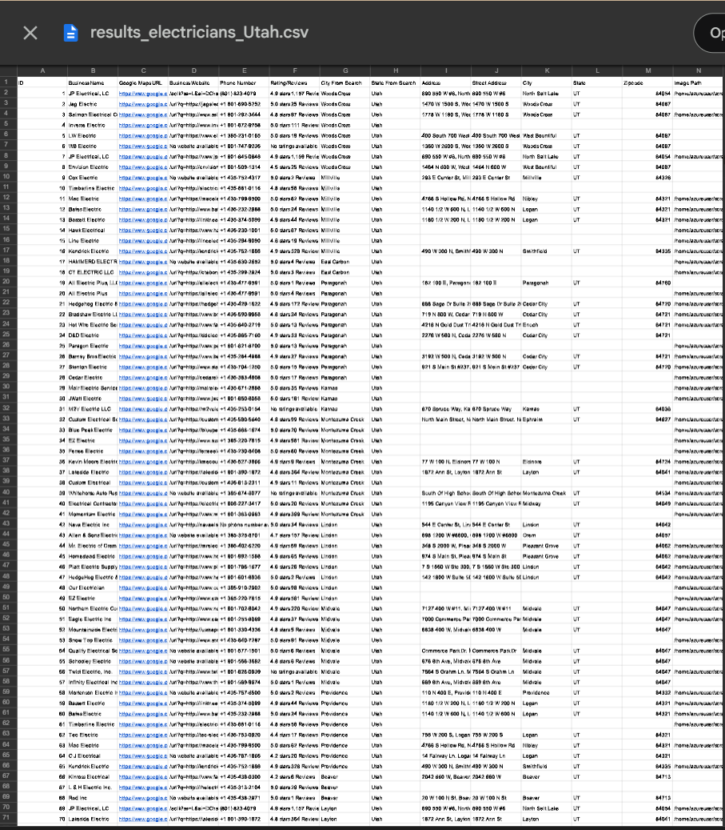

7. Reliability and Error Handling
The project includes several safeguards to make long scraping sessions more stable. Browser health is checked periodically, and if the page or context becomes unresponsive the browser is restarted automatically. Navigation failures use retry logic with backoff delays. Each city is marked as in progress before scraping starts, which helps preserve continuity if the process stops unexpectedly. Failed cities are recorded in a separate log for later review.

8. Data Management and Folder Structure
Output is organized using a clean directory structure under a local root folder. Separate folders are created for data, images, logs, progress files, and heartbeat monitoring. For each category and state, the script generates separate results and reviews CSV files. Image files are saved using sanitized filenames so that the output remains portable across systems.

9. Important Features
- Multi-state scraping with concurrent processing.
- State and city resumption support through progress files.
- Automatic heartbeat updates for monitoring.
- Google Drive synchronization without deleting remote files.
- Structured CSV output for business listings and reviews.
- Image download support for business profile media.

10. Output
The final dataset contains business IDs, names, Google Maps URLs, websites, phone numbers, ratings, search city, search state, addresses, parsed address parts, and saved image paths. A separate review file stores reviewer name, rating, review comment, and review date for each business that exposes reviews on Google Maps.

12. Conclusion
This project demonstrates a practical end-to-end automation pipeline for collecting location-based business data at scale. It combines browser automation, data parsing, fault tolerance, and backup automation into a single workflow suitable for real-world usage. The design focuses on reliability, recoverability, and clean data organization, which makes it suitable for office submission and further enhancement.

